**SHRI GOVINDRAM SEKSARIA INSTITUTE OF TECHNOLOGY AND SCIENCE**

**Department of Computer Engineering**

**B.Tech Computer Science**



**Internship Report**

**3th Year (2020-2024)**

**Submitted By:**

Divyansh Mathiya

0801CS213D02

**INDEX**

|  |  |
| --- | --- |
| **Title** | **Page No.** |
| **INTERNSHIP CERTIFICATE** |  |
| **COMPANY INFORMATION** |  |
| **INTERNSHIP SUMMARY** |  |
| **INTERNSHIP DETAIL REPORT** |  |
| **LEARNING OUTCOME OF INTERNSHIP** |  |
| **INTERNSHIP STIPEND DETAILS** |  |

**INTERNSHIP CERTIFICATE**

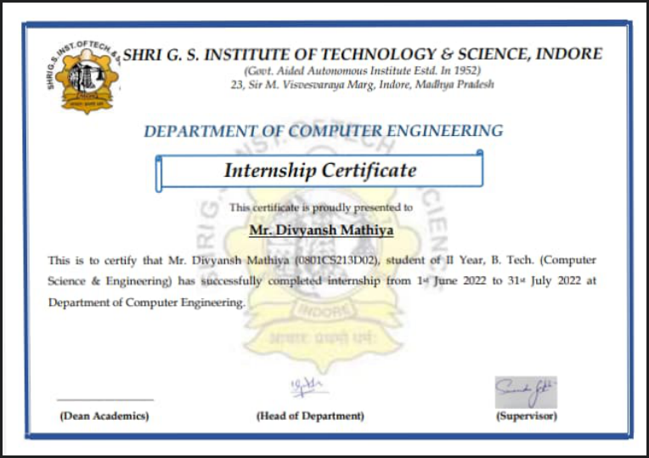

**COMPANY INFORMATION**

**Overview:**

|  |  |
| --- | --- |
| **Company** |  |
| **Website** |  |
| **Address** |  |
| **Title** |  |
| **Mode** |  |
| **Stipend Received** |  |
| **Duration** |  |
| **Time From - To** | June 2022- July2022 |

**Company Name**:

**About Company:**

**INTERNSHIP SUMMARY**

**Title:**

**Duration:**

**Nature of Work:**

**Technologies Used:**

* Technology Used
* Technology Used
* Technology Used
* Technology Used
* Technology Used
* Technology Used
* Technology Used
* Technology Used

**INTERNSHIP DETAIL REPORT**

|  |  |  |
| --- | --- | --- |
| **Month** | **Week** | **Task** |
| **June 2022** | * **Week 1** | * **Technology and platform** |
| * **Week 2** | * **Input files** |
| * **Week 3** | * bo |
| * **Week 4** | * **Bo ->bc** |
| **July 2022** | * **Week 1** | * **Working on alogorithm and compeleting backend** |
| * **Week 2** | * **Desigining and implement Fronted** |
| * **Week 3** | * **testing** |
| * **Week 4** | * **User manual and** |

**LEARNING OUTCOME OF INTERNSHIP**

* **Handling excel files**
* **Java swing for frontend designing**
* **Ada**
* **Github**
* **Teamwork**
* **Sticking to strict deadline**

**INTERNSHIP STIPEND DETAILS**